Create a config and get all running pods:

Get all services running on pod :

Replace client image with worker image:  
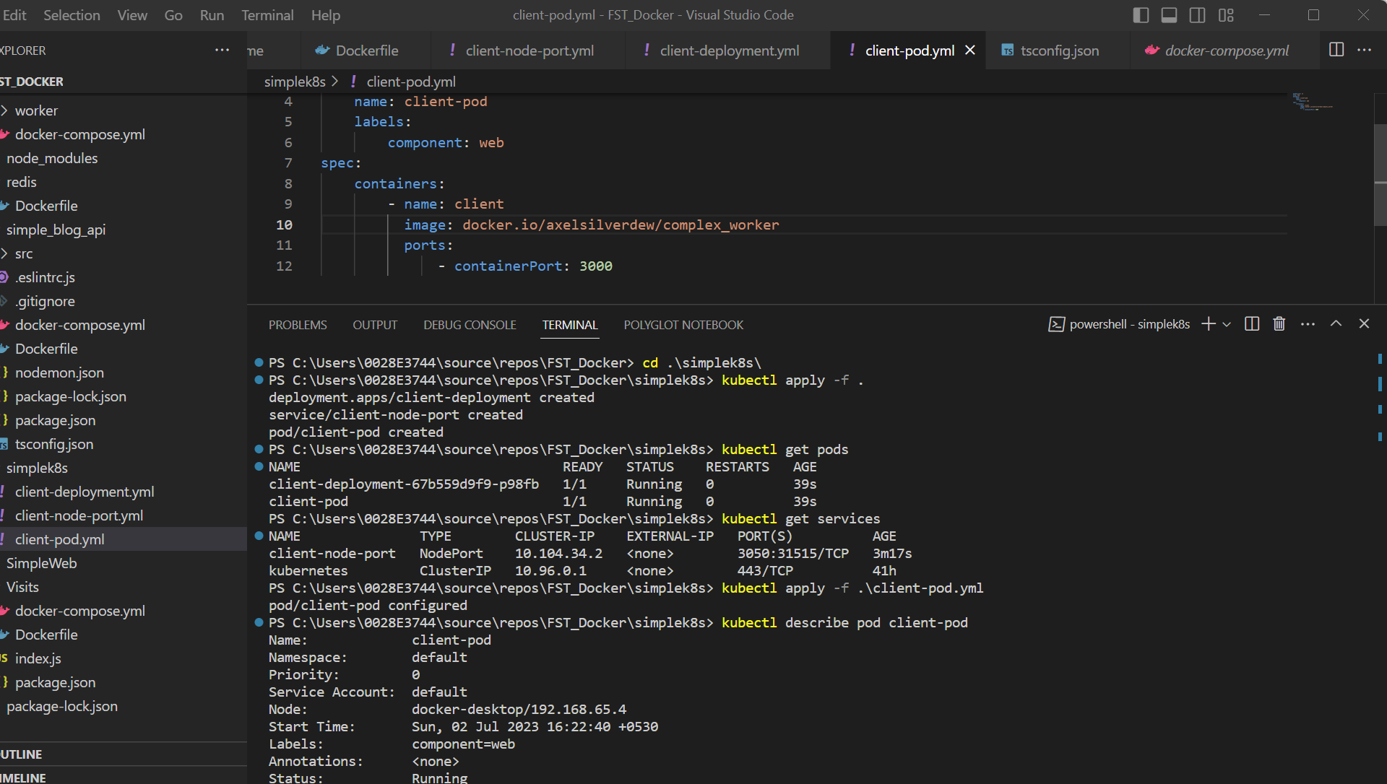

Create deployment :

